DATABASE MANAGEMENT SYSTEM

**Course Code:**

**Second Year Engineering**

Year 2021 - 2022

**Group Members:** 1. Maithili Jagdale

2. Sandhyarani Sonkamble

3. Omkar Dhore

4. Shivkanya Kurude

5. Harshada Bhujbal

**Project Title :** DPES Trip Registration Form

**Name of Mentor :** Prof.Miss. Nehali Shinde

# 

# Second Year IT E ngineering

### SUBMITTED BY

1. Maithili Jagdale

2. Sandhyarani Sonkamble

3. Omkar Dhore

4. Shivkanya Kurude

5. Harshada Bhujbal

# DEPARTMENT OF INFORMATION TECHNOLOGY

**DHOLE PATIL COLLEGE OF ENGINEERING**

**( KHARADI, PUNE )**

**Table of Contents**

|  |  |  |
| --- | --- | --- |
| **Sr. no** | **Contents** | **Page no.** |
| **1** | **Abstract** |  |
| **2** | **Introduction** |  |
| **3** | **Software Requirement Specifications** |  |
| **4** | **Conceptual Design using ER feature** |  |
| **5** | **Relational Model with appropriate Normalized form** |  |
| **6** | **Graphical User Interface** |  |
| **7** | **Source Code:** |  |
| **8** | **Test Cases:** |  |
| **9** | **Conclusion** |  |
| **10** | **References** |  |

1. **Abstract:**

The data is required to be maintained on the students and staff like, name, address, any medical history etc. as a precautionary measurement. Currently this data is stored in the form of excel sheets or in the form of handwritten files. There is a need to automate this feature to the administration department to maintain and retrieve data efficiently.

In this system we are providing the students to insert and update their data and to the admin to view and delete their data from the database.

1. **Introduction:**

As a part of development process of students of the college they are require to undertake trips to the various industries or anything else. This visit may be a part of their curricular or extra curricular activities to boost their enthusiasm within them.

So, this system is designed to manage data for the students who are willing to join the trip.

# Hardware / Software Requirement Specifications

### HARDWARE REQUIREMENTS

* A desktop or laptop with a proper internet connection.
* 20 GB of hard disk (free space)
* Minimum 2GB or Greater of the RAM
* Operating system.(Windows)

### SOFTWARE REQUIREMENTS:

**PHP**

PHP is a server-side scripting language designed primarily for web development but also used as a general programming language PHP code may be embedded into HTML or HTML5 markup or it can be used in combination with various web template systems, web content management systems, and web frameworks. PHP code is usually processed by a PHP interpreter implemented as a module in the web server. The web server software combines the results of the interpreted and executed PHP code, which may be any type of data, including images, with the generated webpage.

### WEB SERVER: Xampp

XAMPP is one of the widely used cross-platform web servers, which helps developers to create and test their programs on a local webserver. It was developed by the Apache Friends, and its native source code can be revised or modified by the audience.

It consists of Apache HTTP Server, MariaDB, and interpreter for the different programming languages like PHP and Perl. It is available in 11 languages and supported by different platforms such as the IA-32 package of Windows & x64 package of macOS and Linux.

### Database: MYSQL

phpMyAdmin is a costless and open source software that provides the functionality of operating and managing [MySQL](https://www.javatpoint.com/mysql-tutorial) over the internet. It provides an ease to the user to control and supervise the database with the help of a graphic user interface known as phpMyAdmin.This GUI is written in [PHP](https://blog.templatetoaster.com/code-first-php-web-page/) programming language. Over time it has gained a lot of trust and demand for the purpose of finding a web-based MySQL administration solution. The user can operate upon MySQL via phpMyAdmin user interface while still directly executing [SQL](https://www.javatpoint.com/sql-tutorial) queries. The [GUI](https://www.javatpoint.com/gui-full-form) allows the host to carry a number of manipulation operations on the database, such as editing, creating, dropping, amending, alteration of fields, tables, indexes, etc.

**ER Diagram:**

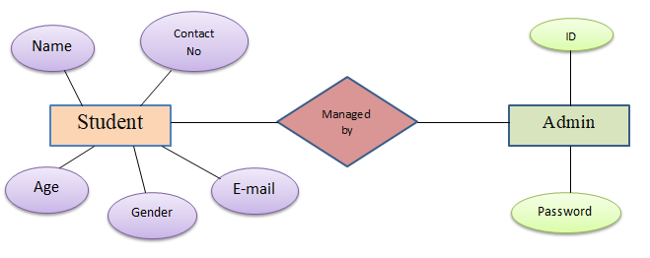

# Relational Model with appropriate Normalized form

### First Normal Form (1NF)

As the domain of all attributes of all relations in the database has atomic value and no tuples can have a set of these values, all relations are in 1NF.

### Second Normal Form (2NF)

As there is no partial dependency in the database, i.e. all nonprime attributes of a relation are fully functionally dependent on the primary key of the relation schema, all relations are in 2NF.

### Third Normal Form (3NF)

As all relations are in 2NF and no non-prime attribute of a relation schema is transitively dependent on the primary key, all relations are in 3 NF.

# Graphical User Interface:

# Source Code:

**FORM:** INDEX.PHP

<?php

$insert = false;

if(isset($_POST['name'])){

    // Set connection variables

    $server = "localhost";

    $username = "root";

    $password = "";

    // Create a database connection

    $con = mysqli_connect($server, $username, $password);

    // Check for connection success

    if(!$con){

        die("connection to this database failed due to" . mysqli_connect_error());

    }

    // echo "Success connecting to the db";

    // Collect post variables

    $name = $_POST['name'];

    $gender = $_POST['gender'];

    $age = $_POST['age'];

    $email = $_POST['email'];

    $phone = $_POST['phone'];

    $desc = $_POST['desc'];

    $sql = "INSERT INTO `dbms`.`trip` (`name`, `age`, `gender`, `email`, `phone`, `other`, `date`) VALUES ('$name', '$age', '$gender', '$email', '$phone', '$desc', current_timestamp());";

    // echo $sql;

    // Execute the query

    if($con->query($sql) == true){

        // echo "Successfully inserted";

        // Flag for successful insertion

        $insert = true;

    }

    else{

        echo "ERROR: $sql <br> $con->error";

    }

    // Close the database connection

    $con->close();

}

?>

<!DOCTYPE html>

<html lang="en">

<head>

    <meta charset="UTF-8">

    <meta name="viewport" content="width=device-width, initial-scale=1.0">

    <title>Welcome to Travel Form</title>

    <link href="https://fonts.googleapis.com/css?family=Roboto|Sriracha&display=swap" rel="stylesheet">

    <link rel="stylesheet" href="style.css">

</head>

<body>

    <img class="bg" src="bg.jpg" alt="DPES">

    <div class="container">

        <h1>Welcome to DPES Trip form</h3>

        <p>Enter your details and submit this form to confirm your participation in the trip </p>

        <?php

        if($insert == true){

        echo "<p class='submitMsg'>Thanks for submitting your form. We are happy to see you joining us for the  trip</p>";

        }

       ?>

        <form action="index.php" method="post">

            <input type="text" name="name" id="name" placeholder="Enter your name">

            <input type="text" name="age" id="age" placeholder="Enter your Age">

            <input type="text" name="gender" id="gender" placeholder="Enter your gender">

            <input type="email" name="email" id="email" placeholder="Enter your email">

            <input type="phone" name="phone" id="phone" placeholder="Enter your phone">

            <textarea name="desc" id="desc" cols="30" rows="10" placeholder="If any suggestion"></textarea>

            <button class="btn">Submit</button>

        </form>

    </div>

    <script src="index.js"></script>

</body>

</html>

**ADMIN:** LOING.PHP

<html>

<head>

    <title>Admin Login</title>

</head>

<body>

 <link rel = "stylesheet" type = "text/css" href = "style1.css">

<form style ="background-image: url('bg2.png');"action="" method="post" name="Login_Form">

  <table width="400" height="725" border="0" align="center" class="Table">

    <?php if(isset($msg)){?>

    <tr>

      <td colspan="1" align="center" ><?php echo $msg;?></td>

    </tr>

    <?php } ?>

    <tr><td colspan="2" align="center"><h1 style=color:red >ADMIN LOGIN</h1></td></tr>

    <tr><td align="center" style=color:black:bold>Username:</td><td><input name="Username" type="text" class="Input"></td></tr>

    <tr>

      <td align="center" style=color:black>Password:</td>

      <td><input name="Password" type="password" class="Input"></td>

    </tr>

    <tr>

      <td> </td>

      <td><input name="Submit" type="submit" value="Login" class="Button3"  onClick="location:/display.php"></td>

    </tr>

  </table>

</form>

<?php session_start(); /* Starts the session */

        /* Check Login form submitted */

        if(isset($_POST['Submit'])){

                /* Define username and associated password array */

                $logins = array('omkar' => '1234','username1' => 'password1','username2' => 'password2');

                $logins = array('maithili' => '****','username1' => 'password1','username2' => 'password2');

                /* Check and assign submitted Username and Password to new variable */

                $Username = isset($_POST['Username']) ? $_POST['Username'] : '';

                $Password = isset($_POST['Password']) ? $_POST['Password'] : '';

                /* Check Username and Password existence in defined array */

                if (isset($logins[$Username]) && $logins[$Username] == $Password){

                        /* Success: Set session variables and redirect to Protected page  */

                        $_SESSION['UserData']['Username']=$logins[$Username];

                        header("location:display.php");

                        exit;

                } else {

                        /*Unsuccessful attempt: Set error message */

                        $msg="<span style='color:red'>Invalid Login Details</span>";

                }

        }

?>

**ADMIN DISPLAY :** DISPLAY.PHP

<!DOCTYPE html>

<html>

    <heed>

        <?php include 'links.php';?>

 </head>

 <body>

<div class="container" style="margin-top:20px">

<div class="row">

<div class="col-md-12">

<div class="panel panel-info">

      <h1 class="panel-heading" align="center">Student Details</h1><br>

      <div class="panel-body">

      <div><a href="INDEX.php">+ ADD NEW RECORD</a></div>

        <div class='table-responsive'>

          <table class='table table-striped'>

          <thead>

            <tr>

            <th>Id </th>

              <th>Name </th>

              <th>Age </th>

              <th>Gender </th>

              <th>Email </th>

        <th>Phone </th>

        <th>Other </th>

         <th>Date</th>

         <th colspan="2">Operation</th>

           </tr>

    </thead>

    <tbody>

      </div>

      </div><!-- Close panel Body -->

</div> <!-- Close Panel -->

</div>

</div> <!-- Close Row -->

</div>

             <tbody>

             <?php

              include 'connection.php';

               $selectquery =" select * from trip";

               $query =mysqli_query($con , $selectquery);

              $nums = mysqli_num_rows($query);

              while($res = mysqli_fetch_array($query)){

             ?>

                    <tr>

                     <td><?php echo $res['id']; ?></td>

                     <td><?php echo $res['name']; ?></td>

                     <td><?php echo $res['age']; ?></td>

                     <td><?php echo $res['gender']; ?></td>

                     <td><?php echo $res['email']; ?></td>

                     <td><?php echo $res['phone']; ?></td>

                     <td><?php echo $res['other']; ?></td>

                     <td><?php echo $res['date']; ?></td>

                     <td><a href="UPDATE.php?id=<?php echo $res['id']; ?>"data-toggle="tooltip" data-placement="top" title="UPDATE">

                     <i class="fa fa-edit" aria-hidden="true"></i></a></td>

                     <td><a href="delete.php?ids=<?php echo $res['id']; ?> "data-toggle="tooltip" data-placement="top" title=""><i class="fa fa-trash" aria-hidden="true"></i></a></td>

                    </tr>

                    <?php

                 }

                     ?>

                 </tbody>

                </table>

            </div>

        </div>

  </div>

  <script>

$(document).ready(function(){

  $('[data-toggle="tooltip"]').tooltip();

});

</script>

 </body>

</html>

**UPDATE OPERATION:** UPDATE.PHP

<?php

include_once 'connection.php';

if(count($_POST)>0) {

mysqli_query($con,"UPDATE trip  set name ='" . $_POST['name'] . "',age='" . $_POST['age'] . "',

 gender='" . $_POST['gender'] . "' ,email='" . $_POST['email'] . "' ,phone='" . $_POST['phone'] . "' ,

 other='" . $_POST['desc'] . "'  WHERE name='" . $_POST['name'] . "'");

//  " UPDATE trip  set id='$id' , 'name' ='$name',age='$age', gender='$gender',email='$email',phone='$phone',other='$desc'  where id= '$ids'";

$message = "Record Modified Successfully";

}

$result = mysqli_query($con,"SELECT * FROM trip WHERE id ='" . $_GET['id'] . "'");

$res= mysqli_fetch_array($result);

?>

<!DOCTYPE html>

<html lang="en">

<head>

    <meta charset="UTF-8">

    <meta name="viewport" content="width=device-width, initial-scale=1.0">

    <title>Welcome to  update Travel Form</title>

    <link href="https://fonts.googleapis.com/css?family=Roboto|Sriracha&display=swap" rel="stylesheet">

    <link rel="stylesheet" href="style.css">

</head>

<body>

    <img class="bg" src="bg.jpg" alt="DPES">

    <div class="container">

        <h1>Welcome to DPES Trip form</h3>

        <p>Enter your details and submit this form to confirm your participation in the trip </p>

        <form  name="index.php" action="" method="post">

        <div><?php if(isset($message)) { echo $message; } ?></div>

        <div><a href="display.php">Student List</a></div>

            <input type="text" name="name" id="name" placeholder="Enter your name" VALUES="<?php echo $res['name']; ?>">

            <input type="text" name="age" id="age" placeholder="Enter your Age"VALUES="<?php echo $res['age']; ?>">

            <input type="text" name="gender" id="gender" placeholder="Enter your gender"VALUES="<?php echo $res['gender']; ?>">

            <input type="email" name="email" id="email" placeholder="Enter your email"VALUES="<?php echo $res['email']; ?>">

            <input type="phone" name="phone" id="phone" placeholder="Enter your phone" VALUES="<?php echo $res['phone']; ?>">

            <textarea name="desc" id="desc" cols="30" rows="10" placeholder="If any suggestion"VALUES="<?php echo $res['other']; ?>"></textarea>

            <button class="btn">update</button>

        </form>

    </div>

    <script src="index.js"></script>

</body>

</html>

**DELETE OPERATION:** DELETE.PHP

<?php

include 'connection.php';

$id= $_GET['ids'];

$deletequery =("DELETE FROM trip WHERE id= $id");

$query= mysqli_query($con,$deletequery);

if($query){

    ?>

    <script>

        alert=('deleted Successful');

        </script>

        <?php

   header('location:display.php');

}

  else{

      ?>

    <script>

    alert=('not');

    </script>

    <?php

  }

?>

**SNAPSHOTS:**

**MAIN FORM:**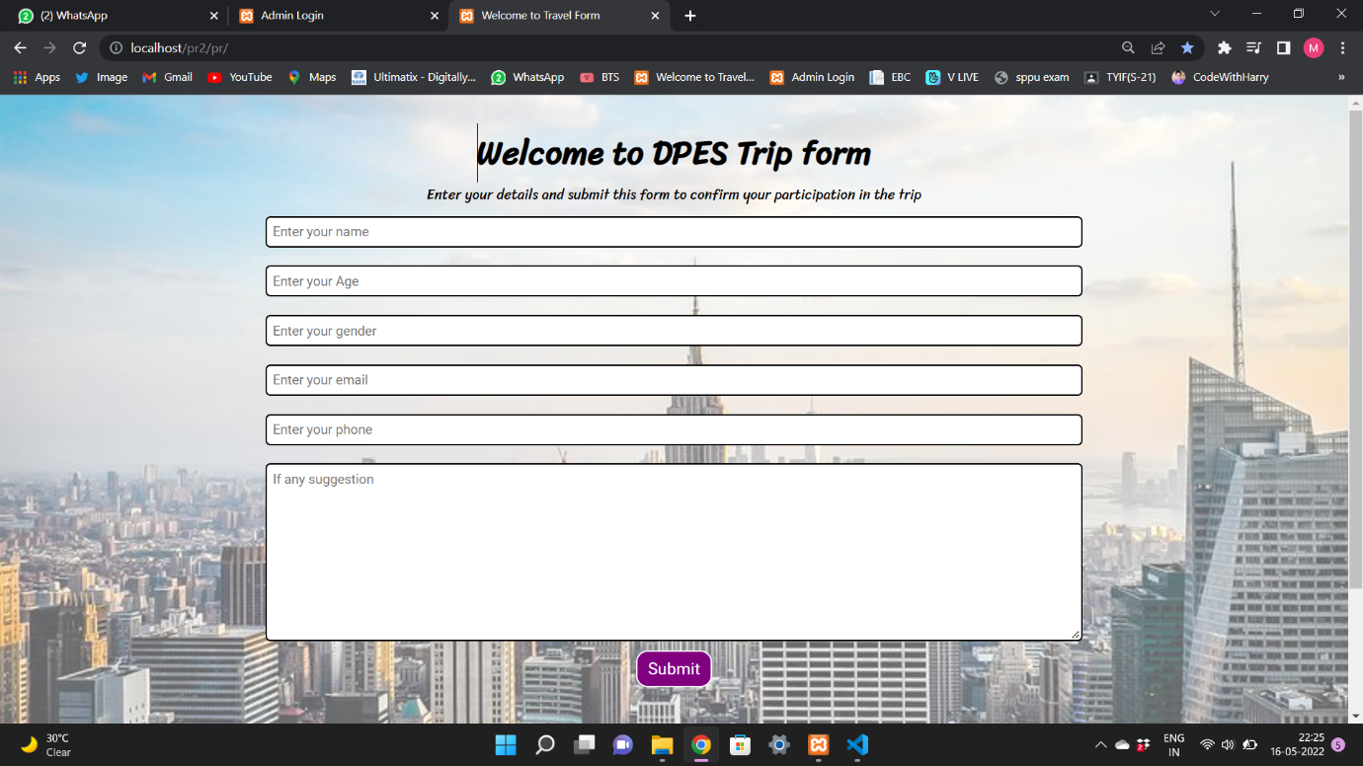

**ADMIN LOGIN:**

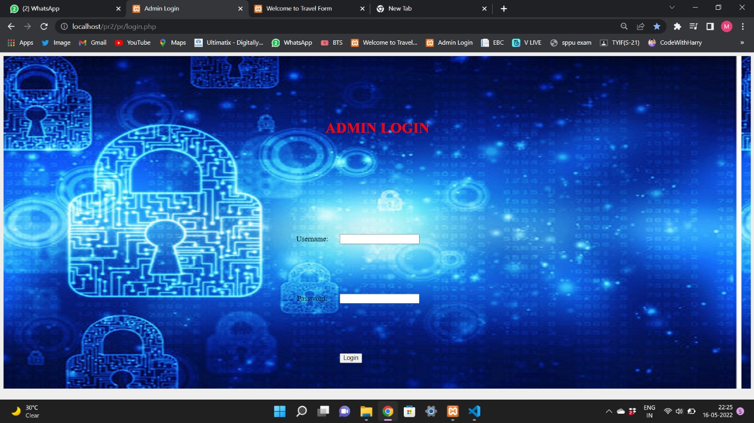

**ADMIN DISPLAY:**

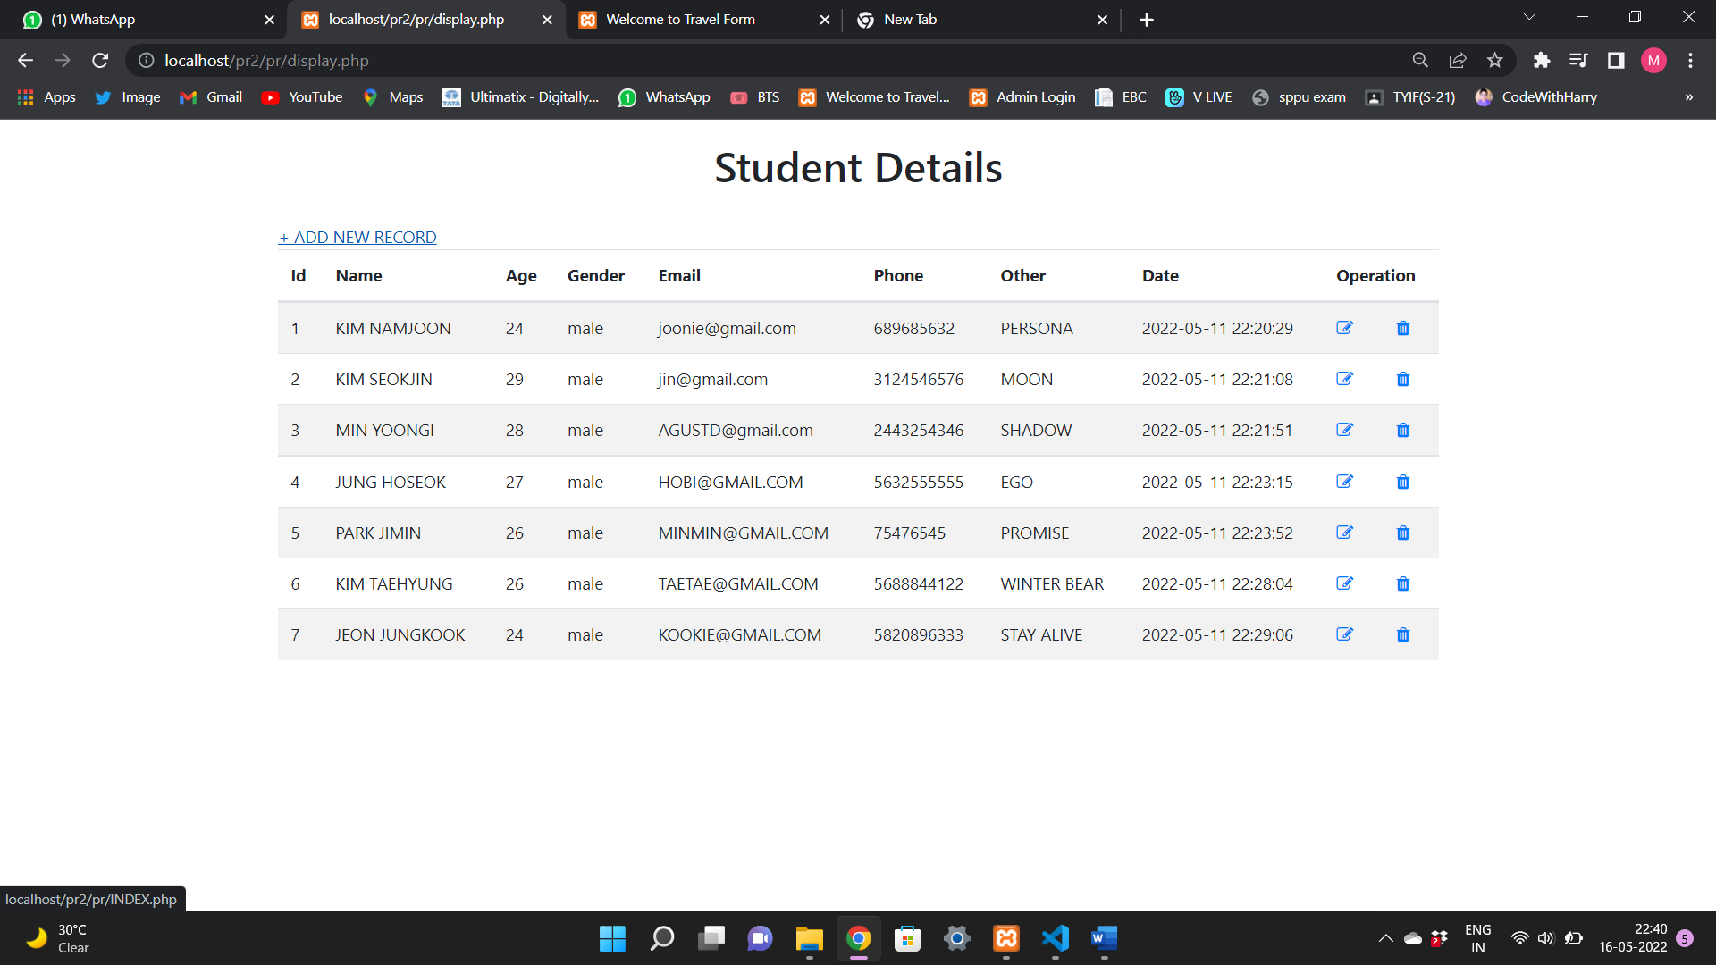

**UPDATE OPERATION:**

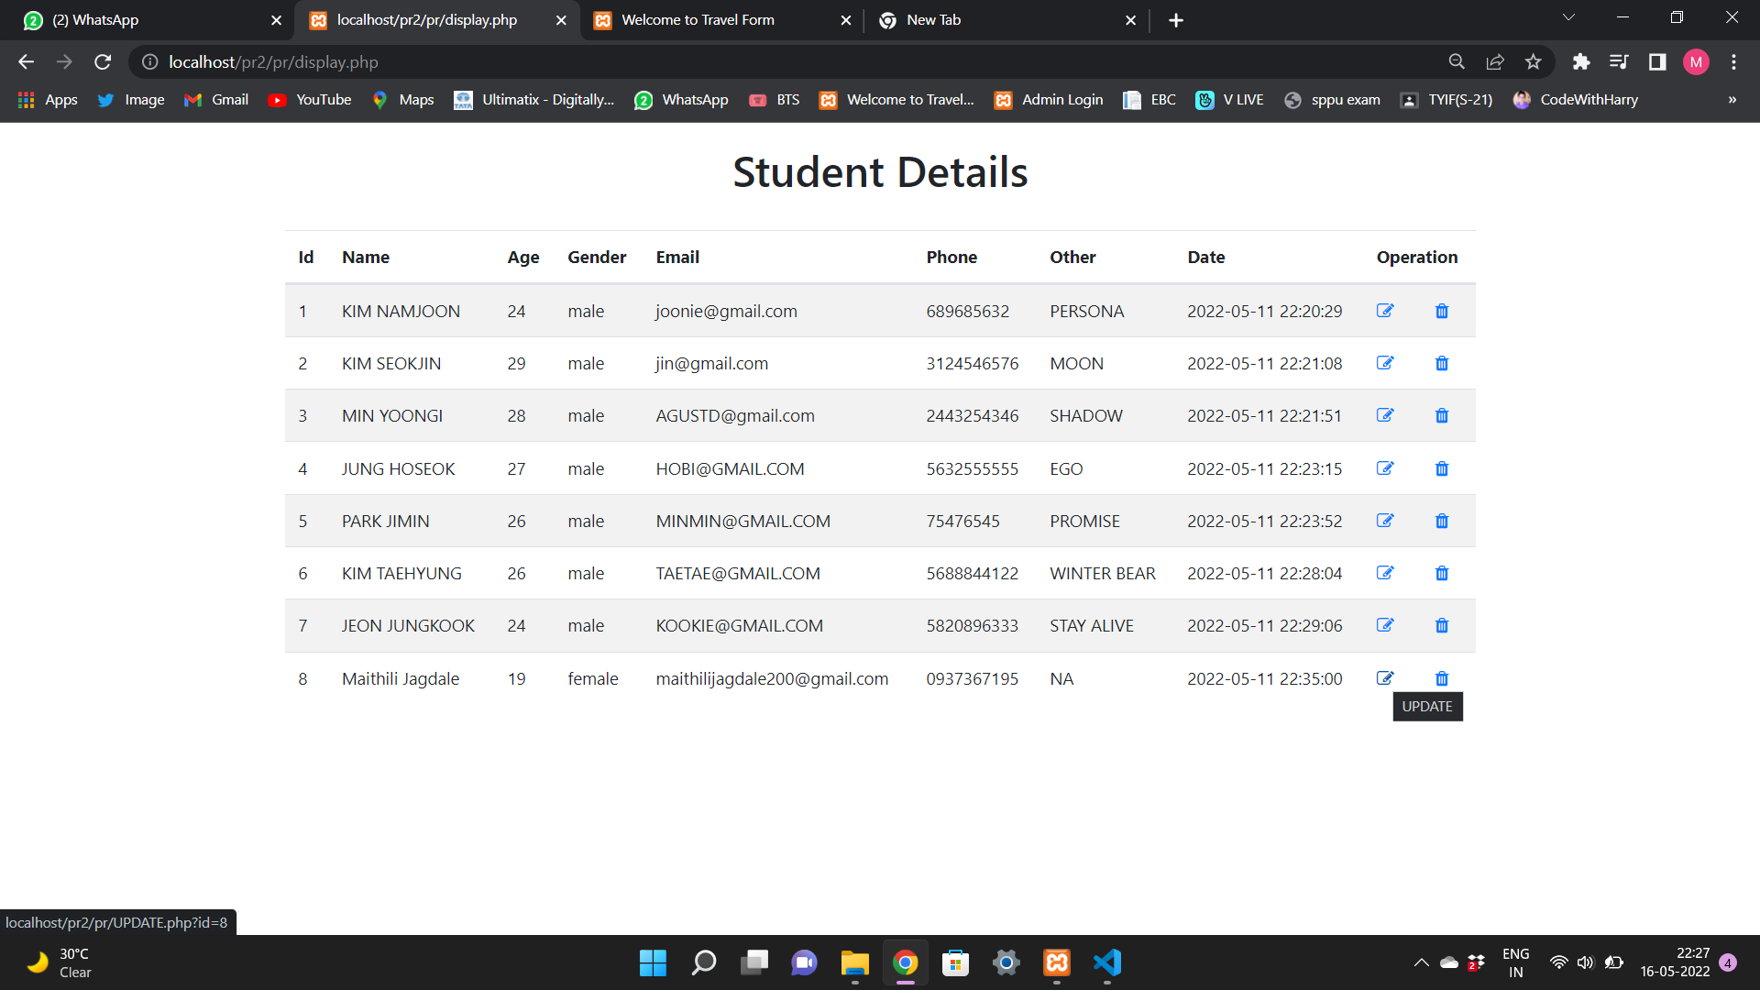

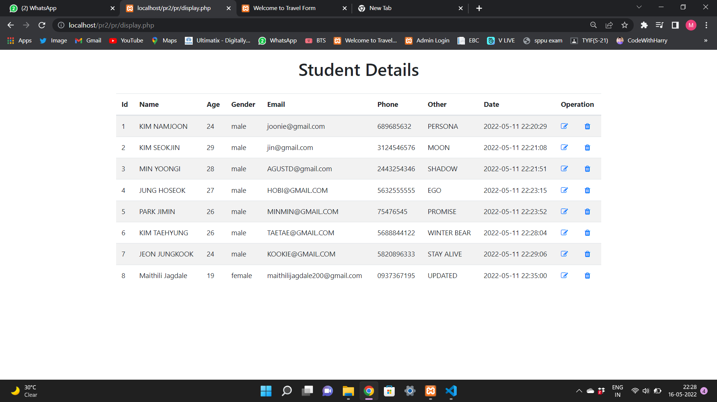

**DELETE OPERATION:**

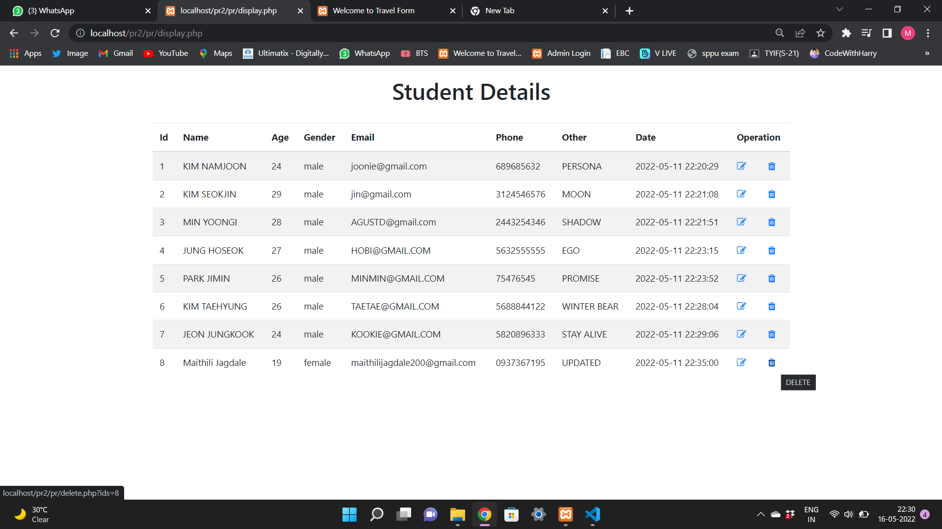

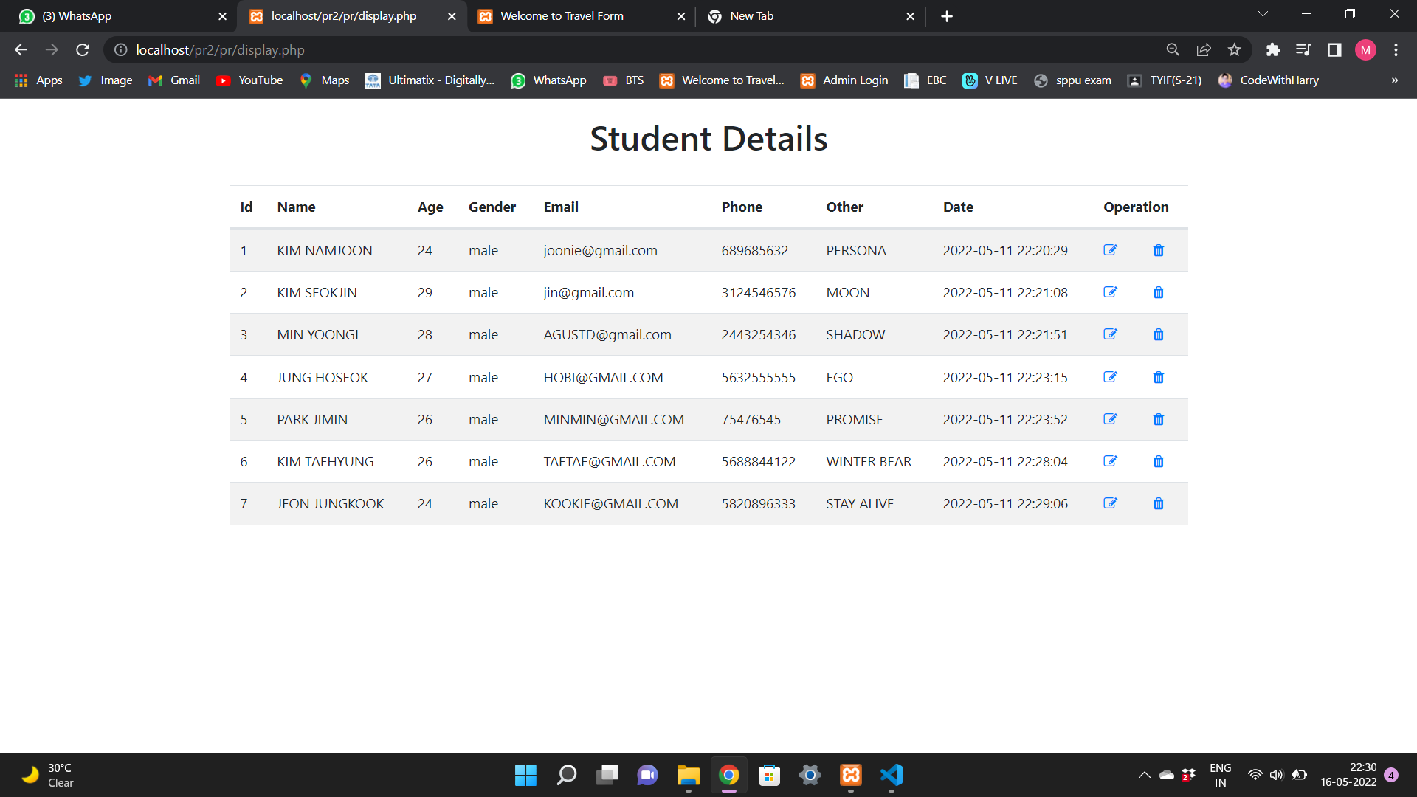

**Modules of Online trip registration form**

* Admin  :
* Admin can create Package.
* Manage packages(Create,Update)
* Manage Data of Users(Students)
* Delete data entered by students
* Admin can view daily, weekly and report this module and also can add, delete, edit and view the data related to students from this module.
* Users :
* Student can register themselves for the trip by entering the required data such as name, age, gender, email-id, phone no or any suggestions if they wanted to give.
* This module provide students to enter their

**Software Requirements**

1. XAMPP Server
2. SQL

**Run/Execute PHP Projects**

1. Open Your Web Browser
2. Put/type inside the web browser : “localhost/project folder”

**Admin Login**

1. Open Your Web Browser
2. Put/type inside the web browser : “localhost/project folder/Admin”
3. Admin User : admin
4. Admin Password : admin